EAST COAST SECONDARY SCHOOL
MIDTERM EXAMINATIONS MARCH 2020
FORM 2 INFORMATION AND COMPUTER STUDIES
TIME: 02:30 Hours
NAME: ________________________________________
Instructions
1. Answer all questions
2. Write your answers in the space provided

1. For each of the following items (i) – (x), underline the correct answer
(i) Times New Roman, Arial and Mistral are all examples of:
A. Style
B. Character
C. Font
D. Size
(ii) Parts of sentence has been emphasized by making it bold and italic. What are bold and italic?
A. Types of style
B. Types of font
C. Types of character
D. Types of alignment
(iii) Most word processing packages have a facility called thesaurus in addition to the usual spell
check. The purpose of this is to:
A. Check the grammar
B. Display alternative words with the same meaning to the one selected
C. Display a word count
D. Display font type
(iv) When you make changes to the content or words on a word processed page, it is called
A. Inserting
B. Formatting
C. Editing
D. Copying
(v) Two common output devices used with word processing systems are
A. Keyboard and mouse
B. Monitor and printer
C. Modem and scanner
D. Speaker and keyboard

(vi) WYSIWYG is an acronym that is often associated with electronic document processing
packages. It stands for
A. What You See Is What You Get
B. What You Save Is What You Get
C. What You Style Is What You Get
D. What You Search Is What You Get
(vii) Which one of the following is not a word processor
A. Word star
B. Word wrap
C. Word perfect
D. Word pro
(viii) To move a picture from one document to another you have to
A. Cut and Copy.
B. Cut and Paste.
C. Copy and Paste.
(ix) Which one of the following is an example of operating system?
A. Microsoft window
B. Microsoft access
C. Microsoft word
D. Microsoft Power Point
(x) Folders are needed to
A. Organize files.
B. Create files.
C. Create documents.
D. Move files
(10 marks)

2. Below is the toolbar used in a word processing program that is required to make changes to the
text in the paragraph. Complete the sentences below by writing the correct number.

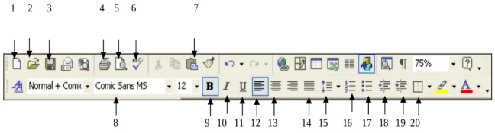
(a) A word program provides the facility to change the font of text according to one’s tastes and
needs. This can be done by pressing icon .........................
(b) One should use icon ............ to include some text in bulleted form and icon _____ to create a
numbered list.
(c) One can type text in bold format by clicking on icon .................
(d) Additionally one may choose to change the line spacing by pressing icon ...................
(e) Sometimes one may need to add a border to a text in order to add more emphasis. This can
simply be done by pressing icon ...................
(f) It is important that before printing we review the whole document. One helpful icon is .............
which allows us to view the work done before printing.
(g) Moreover it essential to recheck the work done for any mistakes and so one may use icon
.............as a short cut to the appropriate tool.
(h) From time to time one should save his/her work by pressing icon ............. to avoid losing the
work done.
(i) Finally, if one intends to print the document done, one could use icon ...................
(10 marks)

3. Look carefully at the screenshot below and then answer the following questions
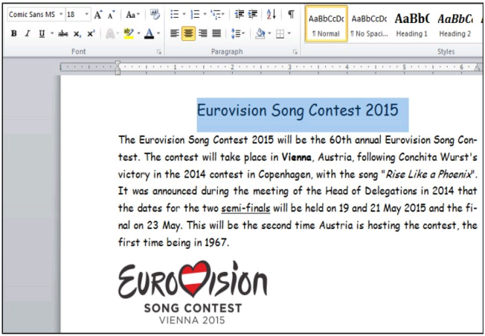

i. The title ‘Eurovision Song Contest 2015’ is using the font type ......................................................
ii. The font size of the title ‘Eurovision Song Contest 2015’ is ...........................................................
iii. The title ‘Eurovision Song Contest 2015’ is aligned ......................................................................
iv. The main paragraph starting ‘The Eurovision Song’ and ending ‘being in 1967’ is aligned
...............................................................................
v. The word ‘Vienna’ in line 2 is formatted ..........................................................................................
vi. “Rise like a Phoenix” in line 3 is formatted ....................................................................................
vii. The word “semi-finals” in line 5 is formatted ................................................................................
viii. The two words that are automatically hyphenated are ..................................................................
and .................................................................................
(20 marks)

4. Look carefully at the Print dialogue box below and answer the questions that follow.
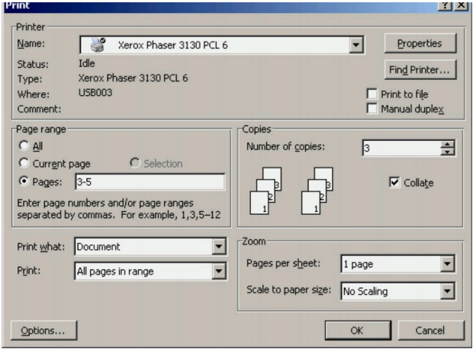

(i) The Print dialogue box can be opened from the ................. bar by selecting .................................
(ii) What is the name of the printer selected? ......................................................................................
(iii) What range of pages will be printed? ............................................................................................
(iv) How many of each page will be printed? .......................................................................................
(v) Describe how you can print all the pages in the document
.........................................................................................................................................................
.........................................................................................................................................................
.........................................................................................................................................................
(20 marks)
5. (a) Define the term electronic word processor
.....................................................................................................................................................
.....................................................................................................................................................
.....................................................................................................................................................
(5 marks)

